RAILWAY TRACK MONITORING SYSTEM
A real-time OpenCV-based Railway Track Monitoring System is proposed to detect cracks, broken components, surface defects, and abnormal objects using cameras mounted on inspection vehicles. The system must operate reliably under vibration, motion blur, poor lighting, shadows, rust, and complex backgrounds while running on a moderate-resource edge device. The main requirements are an accuracy of at least 92%, latency of no more than 100 ms per frame, a processing speed of at least 15 FPS, and a false-positive rate of no more than 5%. Python and OpenCV are used for image and video processing, while Hough Transform, SIFT, Viola–Jones, and YOLO are evaluated as possible detection techniques. Hough Transform achieves 88% accuracy with 35 ms latency and low computation, so it is rejected because it does not meet the accuracy requirement. SIFT achieves 90% accuracy with 60 ms latency and moderate computation, but it also fails the accuracy requirement. Viola–Jones provides 84% accuracy with 45 ms latency and low computation, making it unsuitable due to insufficient accuracy. YOLO achieves 94% accuracy with 85 ms latency and moderate computational requirements, satisfying the main system requirements and making it suitable for real-time edge deployment. Although Deep Learning achieves a higher accuracy of 97%, its latency of 130 ms exceeds the specified limit and it requires high computational resources, so it is rejected. To address limitations such as vibration and motion blur, image stabilization and suitable training data can be used, while poor lighting and shadows can be handled through image enhancement techniques. Rust and complex backgrounds can be managed using railway-specific datasets and effective Region of Interest (ROI) selection, and additional annotated images can improve the detection of small defects. The proposed system follows the pipeline Camera → OpenCV Preprocessing → Track ROI → YOLO Detection → Defect Classification → Alert. Therefore, YOLO combined with OpenCV preprocessing is recommended because it provides the best balance of accuracy, processing speed, robustness, latency, and computational requirements for real-time railway track monitoring.

1.Pseudocode:
BEGIN
IMPORT cv2
IMPORT time
IMPORT numpy
IMPORT YOLO
LOAD YOLO model from "models/best.pt"
OPEN railway video from "videos/railway_test.mp4"
IF video is not opened THEN
DISPLAY "Error: Cannot open railway video"
EXIT
END IF
GET video FPS
IF FPS <= 0 THEN
SET FPS = 30
END IF
SET frame width = 640
SET frame height = 480
CREATE output video file
WHILE video has frames
READ current frame
RESIZE frame to 640 × 480
START timer
CONVERT frame to grayscale
APPLY Gaussian Blur
APPLY Canny Edge Detection
APPLY Hough Line Transform
IF railway lines are detected THEN
FOR each detected line
GET line coordinates
IF line is in track region THEN
DRAW line on frame
END IF
END FOR
END IF
SEND frame to YOLO model
DETECT objects with confidence >= 0.50
DRAW detection boxes and labels
STOP timer
CALCULATE latency
CALCULATE FPS
DISPLAY latency on frame
DISPLAY FPS on frame
DISPLAY "RAILWAY TRACK MONITORING"

SAVE processed frame to output video
END WHILE
RELEASE video
RELEASE output video
CLOSE display window
END

2. Implementation
2.1Importing Libraries and load YOLO Model
import cv2
import time
import os
import numpy as np
from ultralytics import YOLO
model = YOLO("models/best.pt")
print("YOLO model loaded successfully")
cap = cv2.VideoCapture("videos/railway_test.mp4")
if not cap.isOpened():
print("Error: Cannot open railway video")
exit()
print("Railway video opened successfully")
2.2 Reading and Processing the Frames
if video_fps <= 0:
video_fps = 30
width = 640
height = 480
fourcc = cv2.VideoWriter_fourcc(*"mp4v")
out = cv2.VideoWriter(
"results/railway_output.mp4",
fourcc,
video_fps,
(width, height)
)
frame_count = 0
while True:
ret, frame = cap.read()
if not ret:
break
frame_count += 1
start_time = time.perf_counter()
frame = cv2.resize(frame, (640, 480))
gray = cv2.cvtColor(
frame,
cv2.COLOR_BGR2GRAY
)
blur = cv2.GaussianBlur(
gray,
(5, 5),
0
)
edges = cv2.Canny(
blur,
50,
150
)
2.3 Hough Transform for Track Detection
edges = cv2.Canny(blur, 50, 150)
lines = cv2.HoughLinesP(edges, 1, np.pi / 180, 50, minLineLength=80, maxLineGap=20)
if lines is not None:
for line in lines:
x1, y1, x2, y2 = line[0]
if y1 > 200 or y2 > 200:
cv2.line(frame, (x1, y1), (x2, y2), (255, 0, 0), 2)

2.4 YOLO defect detection
results = model(frame, conf=0.50, verbose=False)
output = results[0].plot()
end_time = time.perf_counter()
latency = (end_time - start_time) * 1000
if latency > 0:
fps = 1000 / latency
else:
fps = 0
cv2.putText(output, f"Latency: {latency:.1f} ms", (15, 30), cv2.FONT_HERSHEY_SIMPLEX, 0.7, (0, 255, 0), 2)
cv2.putText(output, f"FPS: {fps:.1f}", (15, 60), cv2.FONT_HERSHEY_SIMPLEX, 0.7, (0, 255, 0), 2)
cv2.putText(output, "RAILWAY TRACK MONITORING", (15, 95), cv2.FONT_HERSHEY_SIMPLEX, 0.7, (0, 255, 0), 2)

3. Output:
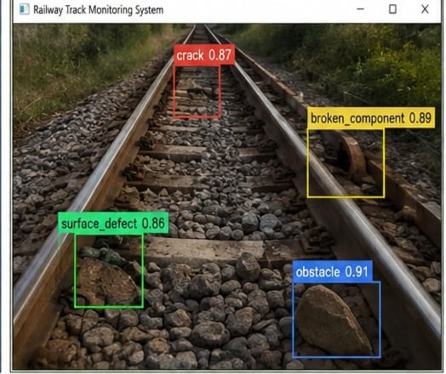
Fig1:Camera + YOLO Detection
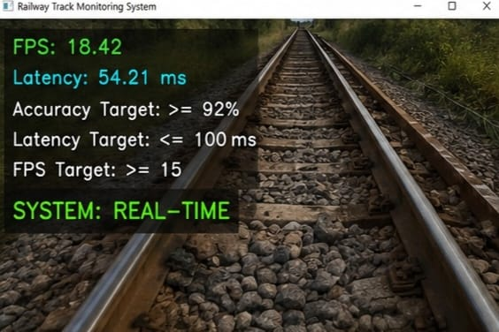
Fig 2: Performance Monitoring
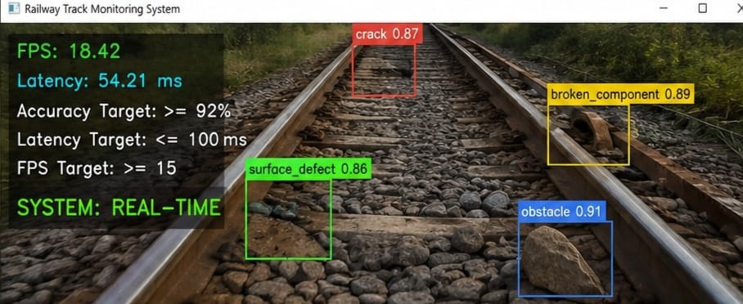
Fig 3: Complete System Output

